Name _______________________________________

Grade One
Spelling Lists for
Unit 3

HOW TO STUDY A WORD:
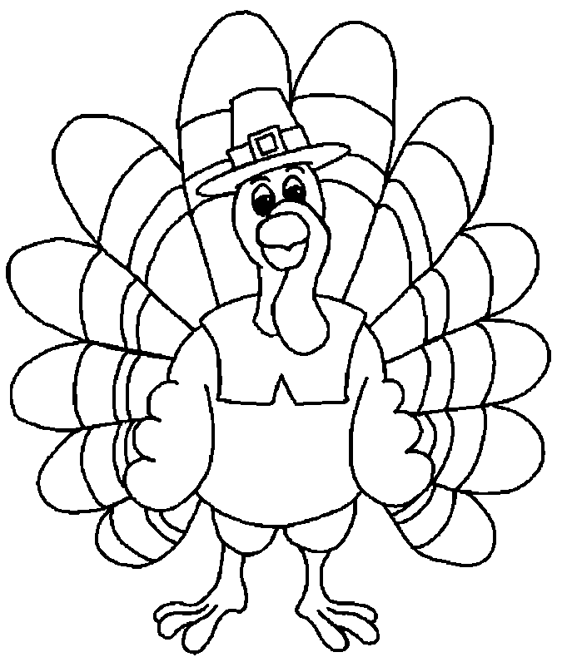
1. LOOK at the word.
2. SAY the word.
3. THINK about the word.
4. WRITE the word.
5. CHECK the spelling.

Students will be tested each week on spelling words. They should be able to read and spell all words for the story. Words may be repeated occasionally.

What Time Is It?

came game gate late make page today

space take away now some why way

Watch It Grow!

bike hide like mine ride shine should

spike twice green grow pretty water together

Tales Over Time

hedge ledge nice page price rice so

wage wedge any from happy once upon

Now and Then

close cube cute hope nose note old

quote rope ago boy girl how people

From Farm to Table

book booklet cook cookie hood look every

took wood after buy done work soon

